CSI-2300 Winter 2025

Yasin Kone ykone@oakland.edu

Chidi Dike cdike@oakland.edu

1. **We started off my making most of if not all of the the declarations**

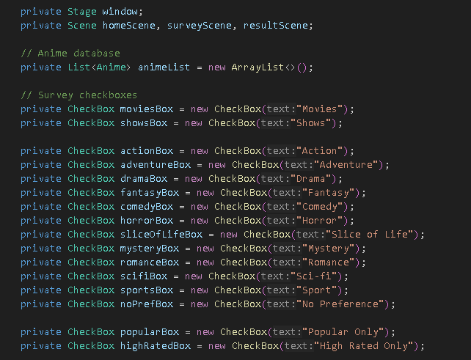

1. **Then we made the Anime class with name, isMovie, isShow, genres, type, isPopular, isHighRated, description**

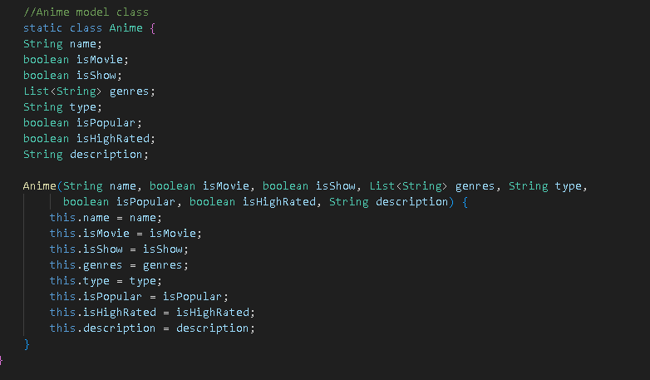

1. **We didnt make this all at the same time but this is where we set up the main page, initialized that anime data, and called the function to set up the survey UI.**

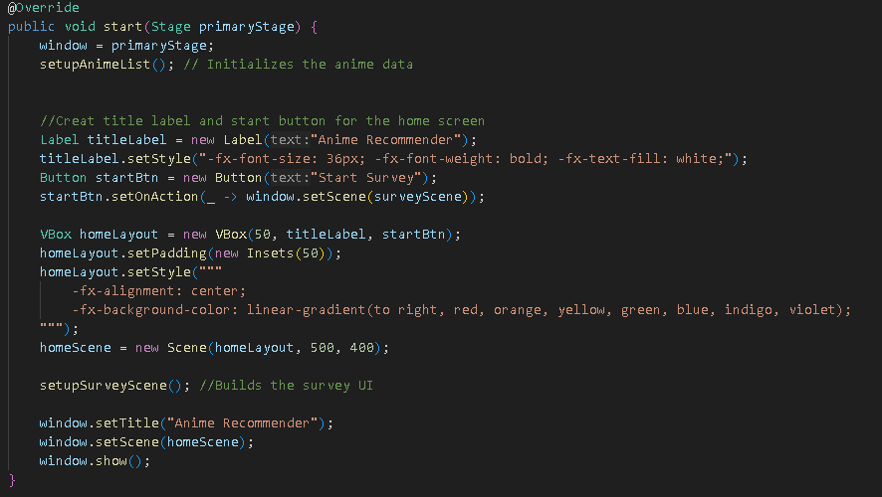

1. **This is where we keep our anime list with hardcoded objects**

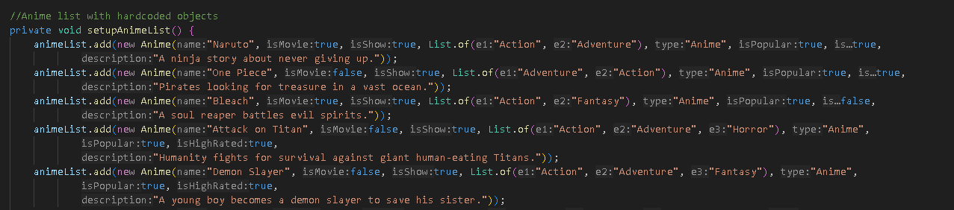

1. **This was where we built the Survey page if you scroll further down you can see more**

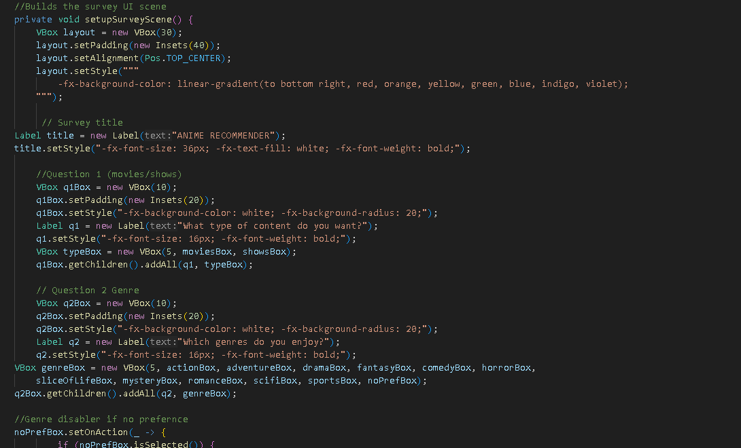

1. **This was where we made our method to show the results and button to go back**

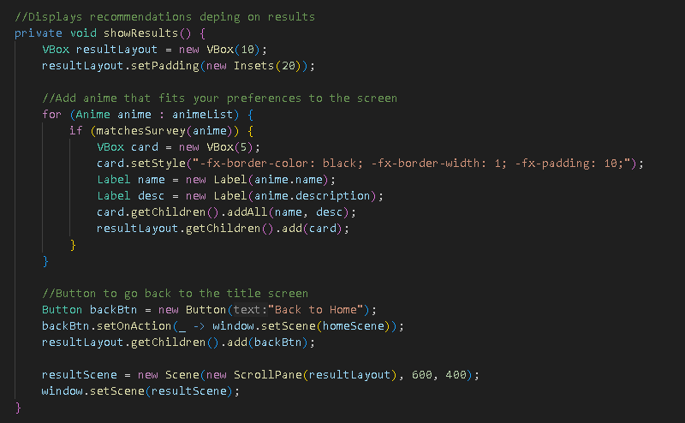

1. **This is where we wrote our logic for the survey**

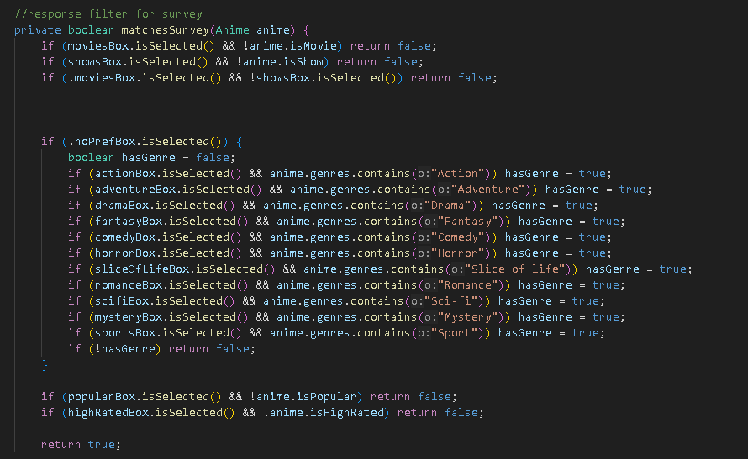

Implementations

* We used Vbox instead of Hbox because when using Hbox we ran into and issue where the words were too close to each other so they overlapped
* We used .setStyle instead of .setFont beacuse when trying to find ways to make the gui spacious and good looking I saw more ways to be creative with .setStyle and I like the padding I dont know if .setFont has a feature like that
* Originally we were working this the TMDB API to recommend users a variety of different shows and movies based off of a much larger and more detailed survey but it proved to be very very difficult to map out the results to specific neishes I did find a video explaining how to do it but it was very outdated so we decided to hardcode everything
* Also originally we had the Anime class in its own file but we ran into issues with run the application so I put it in the main file to no avail until I realized that I accidentally took out of the src folder